Template:
NASLOV RADA/ TITLE OF ARTICLE: TIMES NEW ROMAN, 12 PT, BOLD, UPPERCASE, ALIGNMENT: CENTERED, SPACING: BEFORE 12 PT, AFTER 12 PT, LINE SPACING: SINGLE

Imena autora/Authors name: Times New Roman, 11 pt, Capitalize Each Word, alignment: centered, spacing: before 6 pt, after 6 pt, line spacing: single
  - Apstrakt/abstract: Times New Roman, 11 pt, bold, alignment: justify, spacing: before 6 pt, after 6 pt, line spacing: single
Tekst apstrakta/Abstract text: Times New Roman, 11 pt, alignment: justify, spacing: before 6 pt, after 6 pt, line spacing: single
Ključne reči/keywords: Times New Roman, 11 pt, bold, Italic, alignment: justify, spacing: before 6 pt, after 6 pt, line spacing: single
- Poglavlje prvog reda/Heading 1.: Times New Roman, 12 pt, sentence case, bold, alignment: justify, spacing: before 12 pt, after 12 pt, line spacing: single
  - Poglavlje drugog red/Heading 1.1.: Times New Roman, 12 pt, sentence case, bold, italic, alignment: justify, spacing: before 12 pt, after 12 pt, line spacing: single
    - Poglavlje trećeg reda/Heading 1.1.1.: Times New Roman, 12 pt, sentence case, italic, alignment: justify, spacing: before 12 pt, after 12 pt, line spacing: single
Tekst/Tekst: Times New Roman, 11pt, sentence case, alignment: justify, spacing: before 6 pt, after 6 pt, line spacing: single
Formule/Equations: Equation editor, Calibri math, alignment: centered, spacing: before 6 pt, after 6 pt, line spacing: single. Example:
$$L_{uk}=L_{e}∙N, m$$ | $$(1)$$
gde je/where:
$L_{e}$ - dužina eksplozivnog čepa (m)/length of explosive charge (m),
$N$ - broj minskih bušotina/number of blast holes.

Naziv tabele/Table name: Times New Roman, 9 pt, bold, sentence case, alignment: left, spacing: before 0 pt, after 0 pt, line spacing: single
Tabele/Tables: Times New Roman, 9 pt, sentence case, alignment: centered, spacing: before 0 pt, after 0 pt, line spacing: single

Naziv slike/Figure name: Times New Roman, 11 pt, italic, alignment: centered, spacing: before 0 pt, after 6 pt, line spacing: single
Slika/Figure: alignment: centered, spacing: before 6 pt, after 6 pt, line spacing: single
Literatura/Reference: [1], [2,3], [4-8]

XV MEĐUNARODNA KONFERENCIJA  UGALJ I KRITIČNI MINERALI 2023  Zlatibor, 11-14. oktobar 2023. |  | 15th INTERNATIONAL CONFERENCE  COAL AND CRITICAL MINERALS 2023  Zlatibor, 11-14 October 2023

ANALIZA SEIZMIČKOG DEJSTVA EKSPLOZIJE PRI MINIRANJU NA PRIMERU IZRADE TUNELA GOLUBAC KOD GOLUPCA

ANALYSIS OF SEISMIC EFFECT OF EXPLOSION DURING BLASTING ON THE EXAMPLE OF TUNNEL CONSTRUCTION GOLUBAC NEAR GOLUBAC

Lutovac S., Gligorić M., Majstorović J., Crnogorac L.
  - Apstrakt
Tekst apstrakta.
Ključne reči: ključna reč 1, ključna reč 2, ključna reč 3, ključna reč 4, ključna reč 5
  - Abstract
Abstract text.
Keywords: keyword 1, keyword 2, keyword 3, keyword 4, keyword 5

1. Introduction
Text text text text text text text text text text text text text text text text text text text text text text text text text text text text text text text text text text text text text text text text text text text text text text text text text text text text text text text text text text text text text [1].
Text text text text text text text text text text text text text text text text text text text text text text text text text text text [2,3].
Text text text text text text text text text text text text text text text text text text text text text text text text text text text text text text text text text text text text text text text text text text text text text text text text text text text text text text text text text text text text text text text text text text text text text. Text text text text text text text text text text text text text text text text text text text text text text text text text text text text text text text text text text text text text text text text text text text text text text text text text text text text text text text text text text text text text text text text text text text text text. Text text text text text text text text text text text text text text text text text text text text text text text text text text text text text text text text text text text text text text text text text text text text text text text text text text text text text text text text text text text text text text text text text text text text text. Text text text text text text text text text text text text text text text text text text text text text text text text text text text text text text text text text text text text text text text text text text text text text text text text text text text text text text text text text text text text text text text text text text text text text. Text text text text text text text text text text text text text text text text text text text text text text text text text text text text text text text text text text text text text text text text text text text text text text text text text text text text text text text text text text text text text text text text text text text text text [4-8].
U tabeli 1. Biće prikazani statički nivou i dubine osmatranih pijezometara i jezera.

Tabela 1. Statički nivoi i dubine osmatranih pijezometara i jezera
 | Dubina  (m) | Statički nivo
 |  | S (m) | Apsolutna  kota
PS-4/20 | 50 | 8,50 | 187,22
PS-5/20 | 50 | 6,90 | 187,55
PS-6/20 | 50 | 10,34 | 187,67
PS-8/20 | 47 | 6,76 | 184,74
PS-9/20 | 47 | 9,02 | 186,35
PS-10/20 | 70 | 29,11 | 188,14
BP-1/18 | 23 | 8,75 | 187,50
BP-2/18 | 23 | 9,78 | 196,25
BP-3/18 | 30 | 10,30 | 188,56
Južno jezero | oko 3 m |  | 188,05
Severno jezero | oko 4 m |  | 188,57
Text text text text text text text text text text text text text text text text text text text text text text text text Text text text text text text text text text text text text text text text text text text text text text text text text text text text text text text text text text text text text text text text text text text text text text.
Na slici 1. prikazan je dijagram sniženja nivoa voda u jezerima.
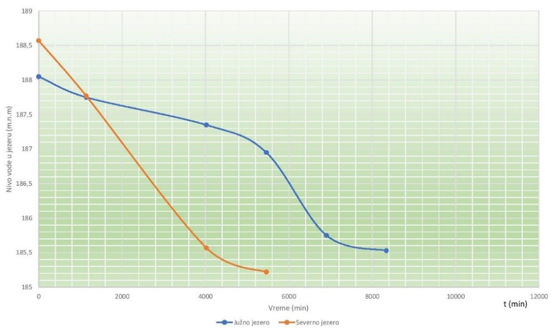
Slika 1. Dijagram sniženja nivoa vode u jezerima

  - Proračun parametara miniranja
Text text text text text text text text text text text text text text text text text text text text text text text text text text text text text text text text text text text text text text text text text text text text text text text text text text text text text text text text text text text text text text text text text text text text text. Text text text text text text text text text text text text text text text text text text text text text text text text text text text text text text text text text text text text text text text text text text text text text text text text text text text text text text text text text text text text text text text text text text text text text. Text text text text text text text text text text text text text text text text text text text text text text text.
    - Dužina minskog punjenja
Proračun ukupne dužine minskog punjenja vrši se po obrascu (1).
$$L_{uk}=L_{e}∙N, m$$ | $$(1)$$
gde je:
$L_{e}$ - dužina eksplozivnog čepa (m),
$N$ - broj minskih bušotina.
Text text text text text text text text text text text text text text text text text text text text text text text text text text text text text text text text text text text text text text text text text text text text text text text text text text text text text text text text text text text text text text text text text text text text text. Text text text text text text text text text text text text text text text text text text text text text text text text text text text text text text text text text text text text text text text text text text text text text text text text text text text text text text text text text text text text text text text text text text text text text. Text text text text text text text text text text text text text text text text text text text text text text text.

Literatura/References
- Ongen, T., Karakus, D., Konak, G., Onur, A. H. (2018): Assessment of blast-induced vibration using various estimation models in Journal of African Earth Sciences, 145, 267-273
- Xu, Q., Wang, Z. Q. (2021): Model for calculating seismic wave spectrum excited by explosive source in Shock and Vibration
- Gonen, A. (2022): Investigation of Fault Effect on Blast-Induced Vibration in Applied Sciences, 12(5), 2278
- Jovanović, P. (1990): Izrada jamskih prostorija, Rudarsko-geološki fakultet, Beograd
- ISO 50001:2018 Energy management systems - Requirements with guidance for use, https://www.iso.org/publication/PUB100400.html
- Bureau Veritas Certification, Management System Certification, Audit Report for the ISO 50001:2018, Recertification audit of Elektroprivreda Srbije JP Beograd - Ogranak RB Kolubara, Lazarevac, Serbia, 06.-08.09.2021.
- FI.6.1.2.0.6 Usaglašenost zakonskih i drugih zahteva upravljanja energijom, Broj: 05, Datum: 22.03.2022.
- Pravilnik o obrascu godišnjeg izveštaja o ostvarivanju ciljeva uštede energije (Službeni glasnik RS, broj 32/16)

Prof. dr Lutovac Suzana, Rudarsko-geološki fakultet, Beograd, suzana.lutovac@rgf.bg.ac.rs
Doc. dr Gligorić Miloš, Rudarsko-geološki fakultet, Beograd, milos.gligoric@rgf.bg.ac.rs
Majstorović Jelena, Rudarsko-geološki fakultet, Beograd, jelena.majstorovic@rgf.bg.ac.rs
Crnogorac Luka, Rudarsko-geološki fakultet, Beograd, luka.crnogorac@rgf.bg.ac.rs

